

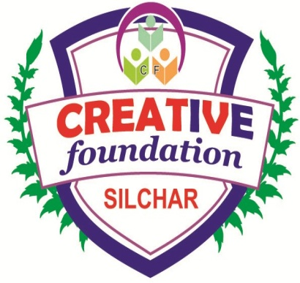

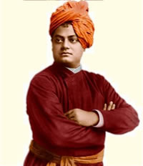

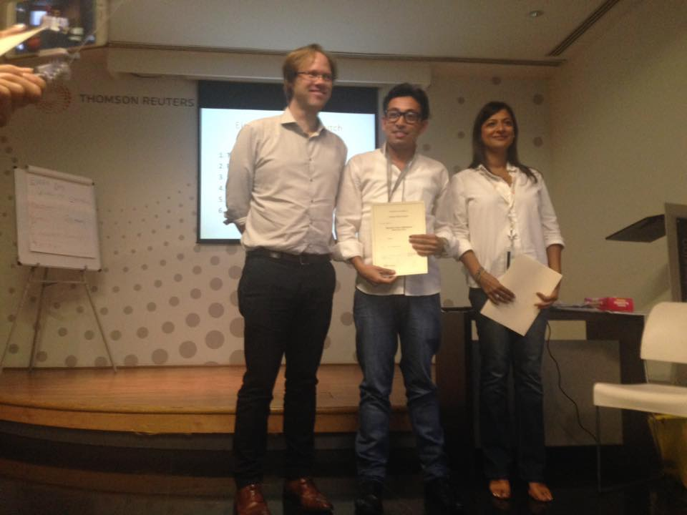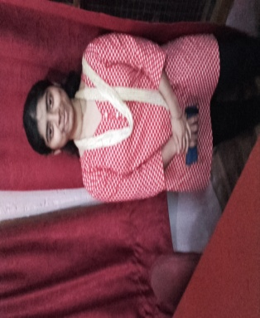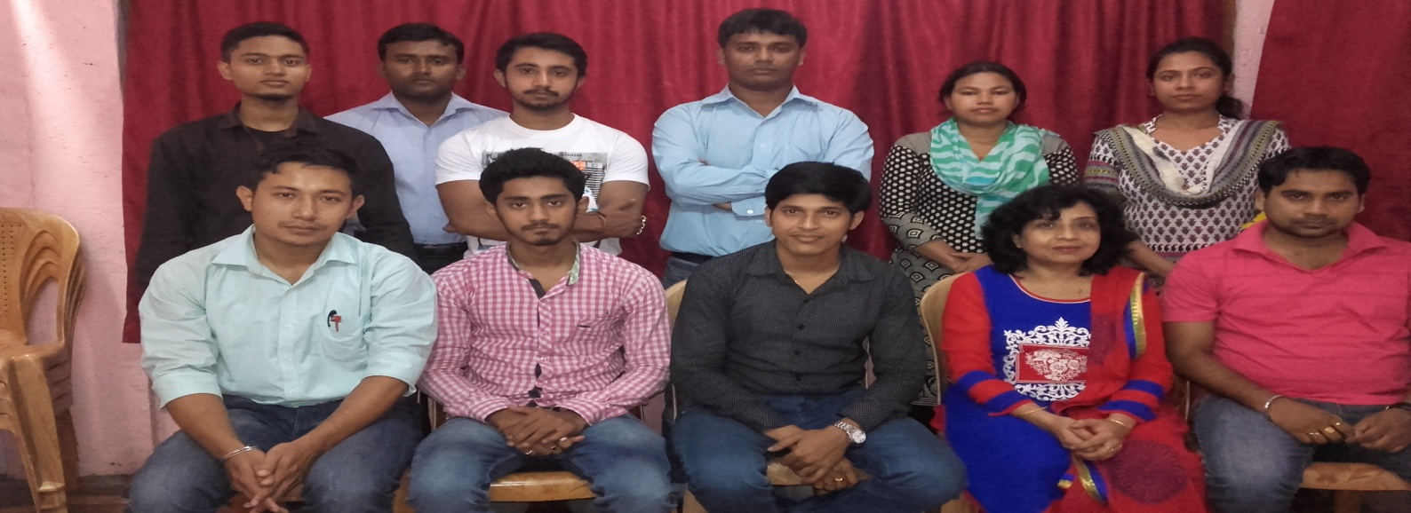

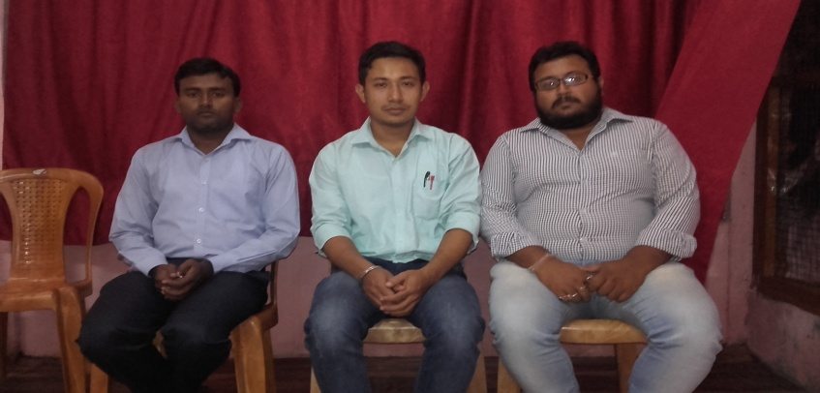

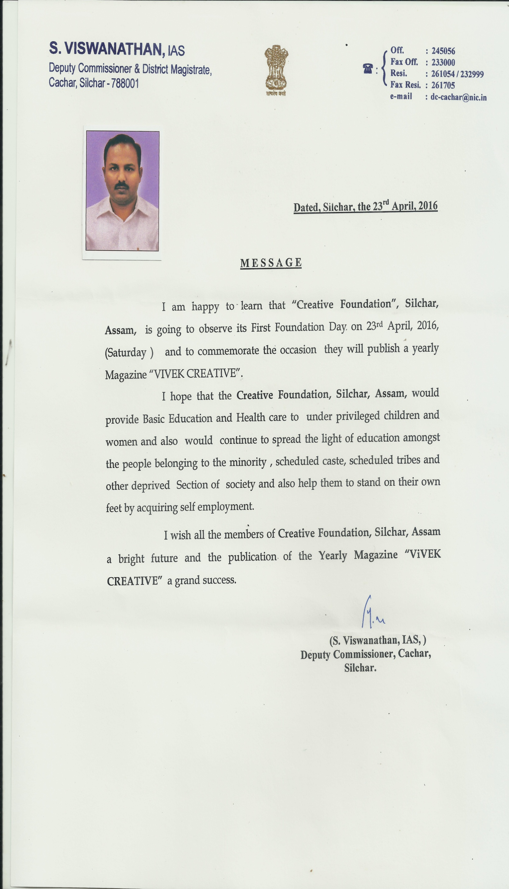

**Contents:**

# A glimpse of creative foundation

# Editorial

# From the Desk of Head of Creative Classes, IIITSilchar, Career Academy and Direction.in

#Creative Foundation at a glance

#Creative Foundation in media

#My Journey with CREATIVE Foundation

#From the members of Creative Foundation

# Visitors of the Year

**A glimpse of creative foundation:**

**Creative foundation is a Registered Society by Assam Govt. under Act 21 - 1860. This Society is providing Technical Training & Developed Technical skills to Youths in the rural areas of Assam. It is also running Social awareness Program in Backward & rural areas.**

**The aim of this society is providing technical training & skill development to the unemployed in Assam & Other states in India. For this, society has an institutional organization named Creative Classes, Institute of Industrial and Information Technology (IIIT), Career Academy and Direction. in. We believe that education is an ongoing process and it never ends. We train our students to passionately seek truth. We kindle their enquiring minds to question, to analyze and to reason. All our curricula and the changes we carefully incorporate aim at these. We teach our students to plant their feet firmly on the land and to let their minds roam among the stars.**

**Our mission is not just providing a solid educational foundation but to build their careers, to make them eminent personalities in the society and to make the industry doors open to them. Creative foundation always believes in making a difference in the field of education to make our institute to the peak of success.**

**Secretary, Creative Foundation**

**সম্পাদকীয়**

**বসন্তের অন্তিম লগ্নে ক্রিয়েটিভ ফাউন্ডেশন, নতুন বছরের নতুন আলোয় গড়বে গৌরবের আরেকটি বছর I এই আশা নিয়ে আমাদের পথ চলা, আর এই পথ চলায় সাক্ষ্য হয়ে থাকবেন কিছু নক্ষত্র যারা আগামীদিনের ভবিষ্যত I ক্রিয়েটিভ ফাউন্ডেশন এর প্রচেষ্টায় শুরু হয়েছে ক্রিয়েটিভ ক্লাস্সেস , আই.আই.আই.টি শিলচর , ক্যারিয়ার একাডেমি এবং ডাইরেকশন.ইন I এই প্রতিষ্টান গুলির নিরলস পরিশ্রমে শত শত ছাত্র ছাত্রীরা আজ নিজ স্বপ্নের শিখরে পৌছতে পেরেছে বলে আমরা আনন্দিত I**

**ক্রিয়েটিভ ফাউন্ডেশন এর বার্ষিক মুখপত্র হল বিবেক ক্রিয়েটিভ এবং এটি তার প্রথম সংখ্যা I এই মুখপত্রটি ক্রিয়েটিভ পরিবারের মনের অন্তরালে লুকিয়ে থাকা ধ্যান – ধারণা, চিন্তা -ভাবনার মুক্ত আকাশ I**

**যাদের সার্বিক সহযোগিতায় এই মুখপত্রটি পূর্ণরূপ পেয়েছে তাদের প্রতি আমরা আন্তরিক ভাবে কৃতজ্ঞ I**

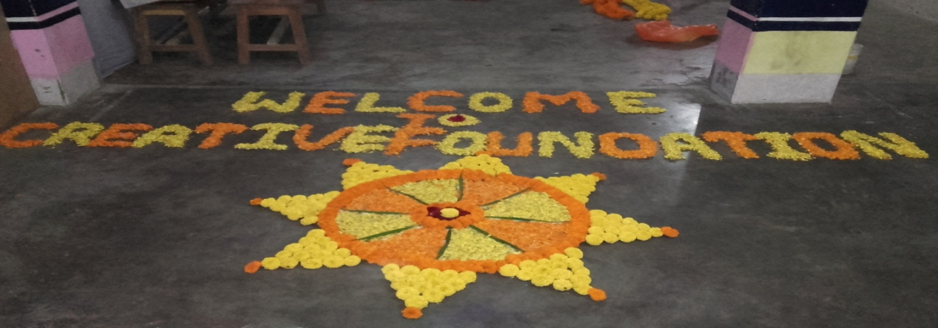 সম্পাদক

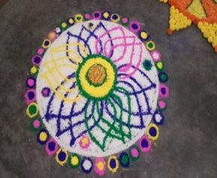

From the Desk of Head Academics, Creative Classes:

**As we move along the trajectory of advancements, we see that there remains no life untouched by the lead of innovation. Each individual though enclosed in its periphery, is being influenced by it in some way or the other. This innovation, when fused with education, can do wonders and the entire world then, may seem to be approaching perfection. We at Creative thus aim to create such levels of perfection, creating an environment of education like never before. We appreciate your will and courage in choosing the best and most challenging academic endeavor at your level. At CREATIVE CLASSES we have restructured our subject courses to incorporate the preparation of board exams along with the preparation of advance subject test. We believe that this will cut down duplicacy of effort of students and will maximize their efficiency. Our study material incorporate exercise based on board exams type question along with the advance subject questions. Periodic tests are held based on board exam pattern along with the regular JEE (Main & Advance) AIPMT style tests. It is our endeavor to enrich our students both in terms of quality and quantity and thus we provide them a platform where they get enough time to target their goals and live their dreams.**

Head Academics, Creative Classes

From the Desk of Academic Advisor

From the Desk of Academic Advisor, IIIT Silchar:

**It is our endeavor to ensure that we provide quality and affordable education at many places possible through our Institute to produce effective, talented, and trained manpower in the field of IT, ITI and professional course. Through our Institutes, it will always be our effort to develop raw talent into quality talent and for this we are in the verge of opening our IT Services section through which we will place our trained students for On-Job-experiences after finishing their courses and make them Future-Ready to join in any position across the globe.**

**Institute of Industrial and information Technology (IIIT) also in tie-up with Universities and leading Government organizations to hand out Diplomas in various disciplines of IT and Vocational Courses locally so that student’s donot have to spend a fortune to get the similar diplomas by studying out of the region.**

**Academic Advisor, IIIT Silchar**

From the Desk of Academic Coordinator, Career Academy:

**Making the world a better place to live is a continuous endeavor of all human beings. We all work to the best of our capability to make life easier & better. The driving force to make things better is INNOVATION. Innovation is not only about making radical or revolutionary changes rather it is the art of making small but significant changes that make life more comfortable.**

**Our effort at Career Academy is not only to provide the students with a road map to effective learning but also to reassure them of our motivating company during their journey on the road to success. Career Academy aims to develop amongst its students a competitive attitude along with sound academic base with quality teaching and individual attention as its hallmark. The Academy organizes seminars and workshops with the help of civil servants and experts in soft skills to train the aspirants to think, feel and express like administrators. This comprehensive approach towards IAS preparation has received an over helming response and has led to the pan India presence of Career Academy**

Academic Coordinator, Career Academy

From the Desk of Head Administrative, Direction.in:

Direction.in is an accomplished name, renowned for providing quality services in the Human Capital and Man Power.We equip our esteemed clients with valuable business solutions for Recruitment, Executive Search, Staffing, Corporate Trainings, HR and RPO (Recruitment Process Outsourcing). We provide comprehensive manpower solutions across all levels and diverse functional areas & deal with multiple functional verticals distributed across the industry.

We are a team of energetic, innovative and experienced intellectuals offering brilliant and tailored business solutions. Our efficient, objective focused solutions supplement the steady growth of individuals and enterprises. The team at Direction.in represents an integration of talent, values and expertise and believes in delivering speedier quality services within set deadlines

Head Administrative, Direction.in

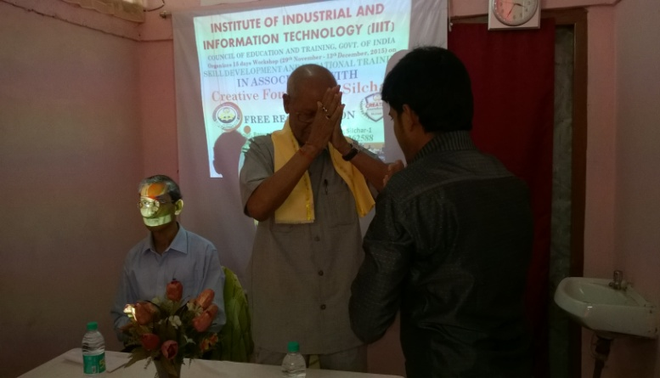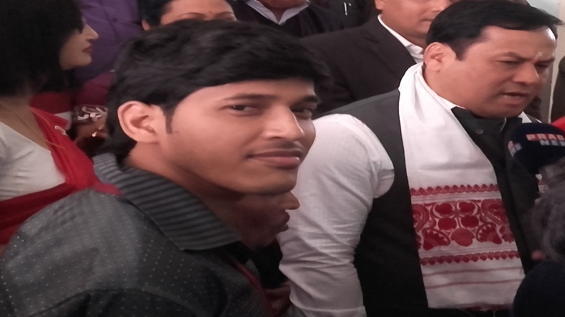Creative foundation at a glance

Founder, Creative Foundation in a workshop with Chairman, Silchar Municipal Board in a workshop with

Union Minister of sports and Youth affairs. founder, Creative Foundation.

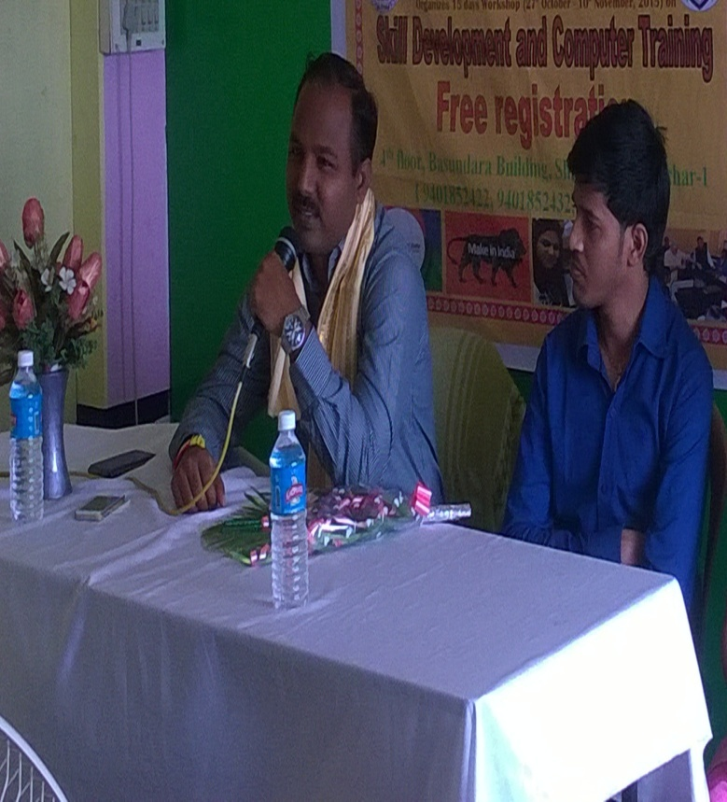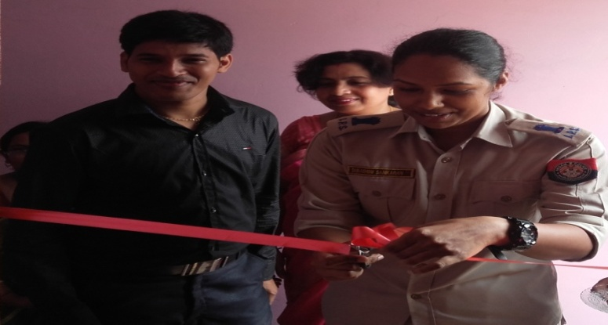

S. Viswanathan, IAS, D.C Cachar along with founder S. Shankaran, IPS, SP Hailakandi, with Founder

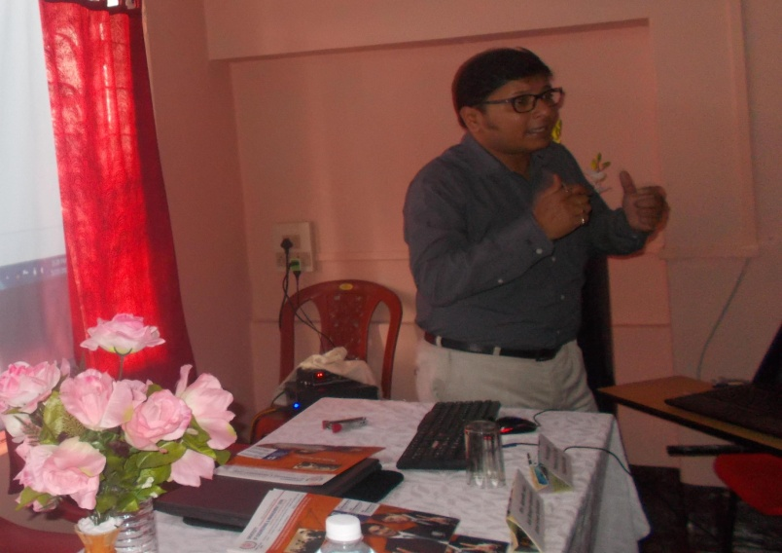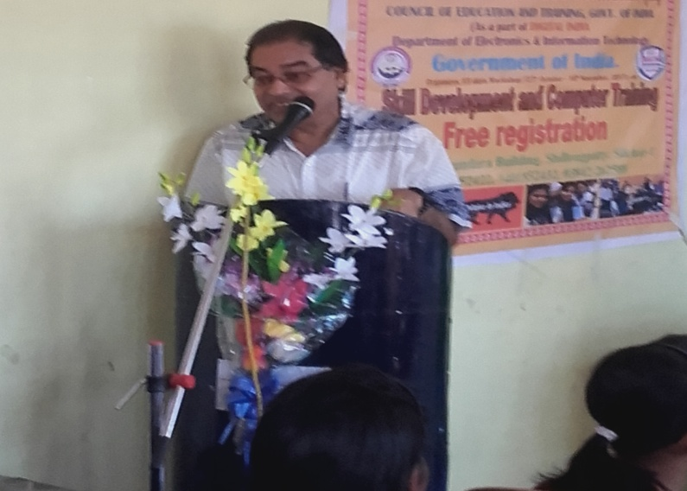

***Creative Foundation at a glance:***

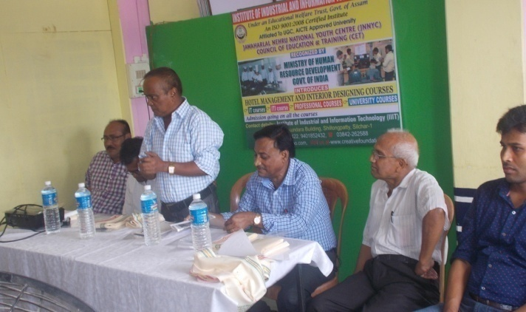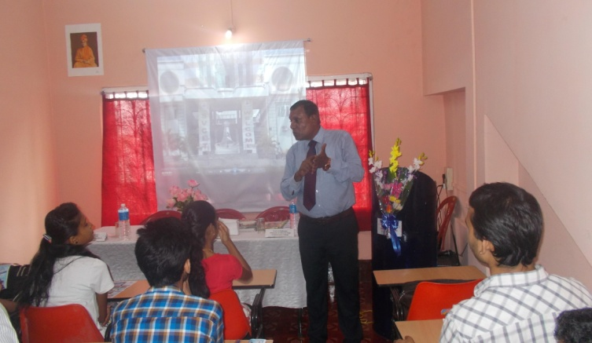 ***Prof. (Dr.) S.B Paul, Ex controller of Exam, Assam University Prof.K. kundu, University of Engineering and Management, Jaipur***

Prof. S.R Rajkumar, Sri venkateswara College, Principal Silchar Polytechnic with

Chittoor, addressing the students on seminar professors of NIT and other colleges on a seminar

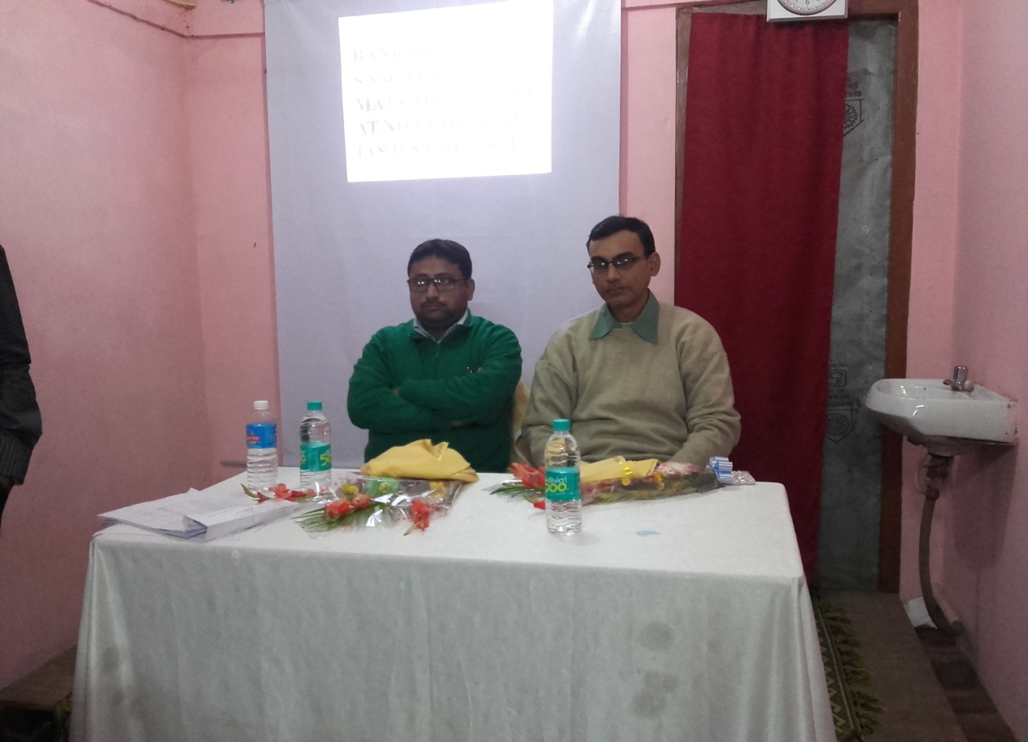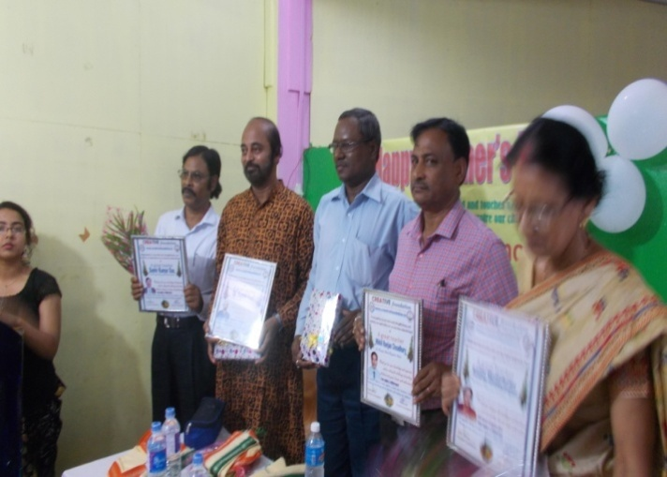

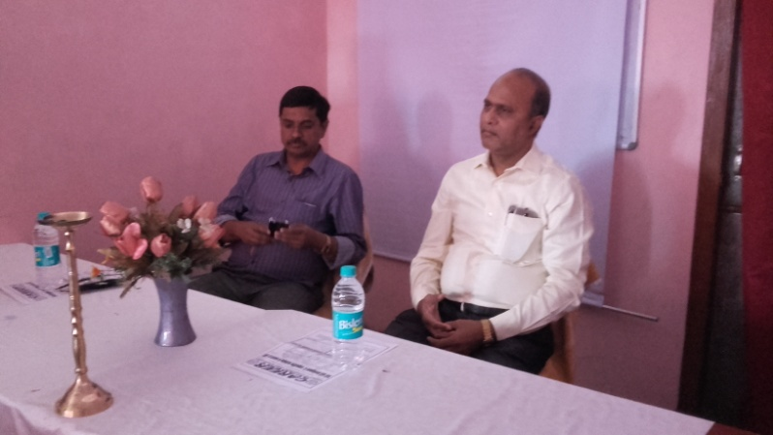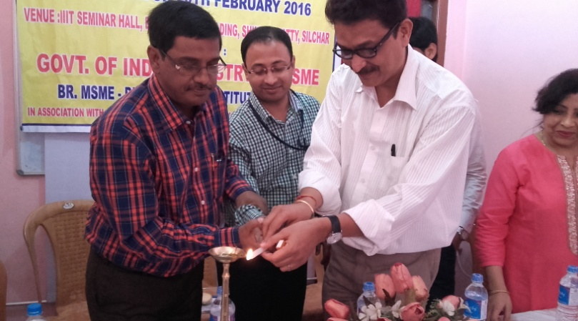***Principal Women’s Cllege with other teachers Dr. A. Nag,G.C College and S. Gupta,Radhamadhav College***

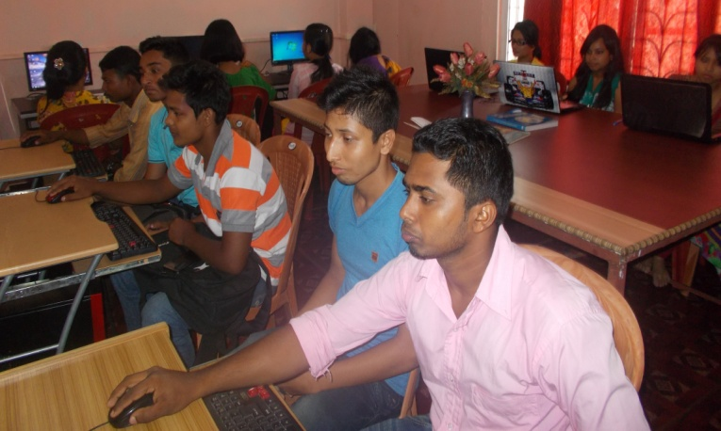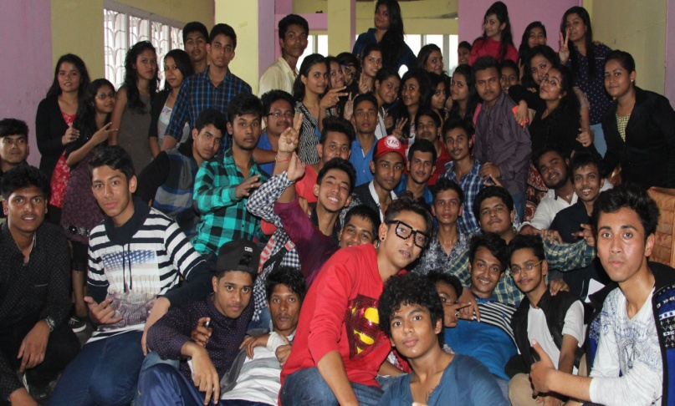***Lead Distric Manager, UBI in a programme joinlty organized by IIIT & MSME Principal, G.C College in a programme of Career academy***

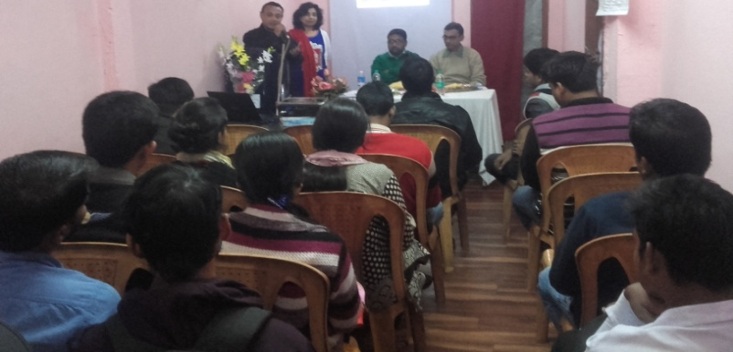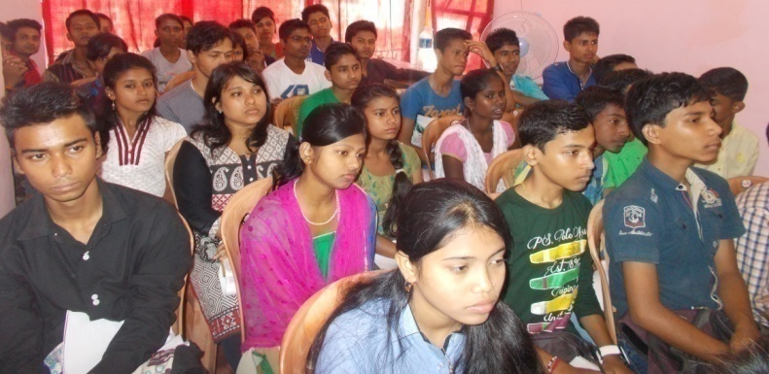***Students of Creative Classes in a programme Students of IIITSilchar in the computer Lab***

***Students of Career Academy in a Seminar Students in a workshop orgenized by Direction.in***

***Creative Foundation in media***

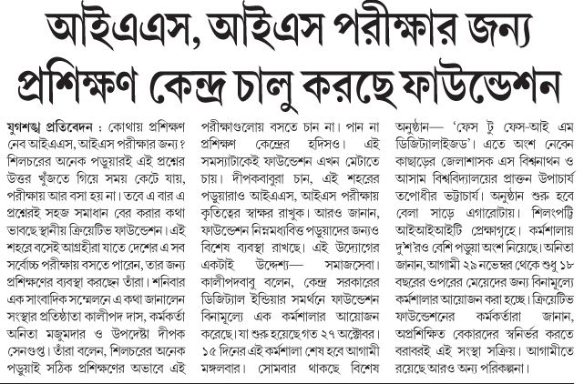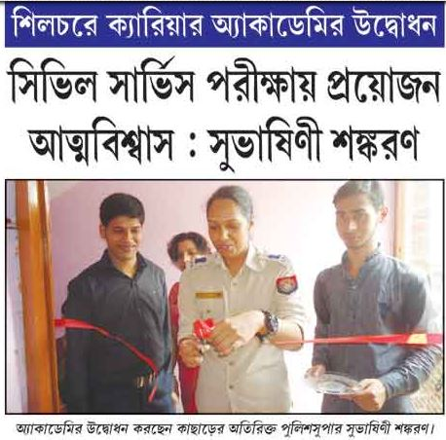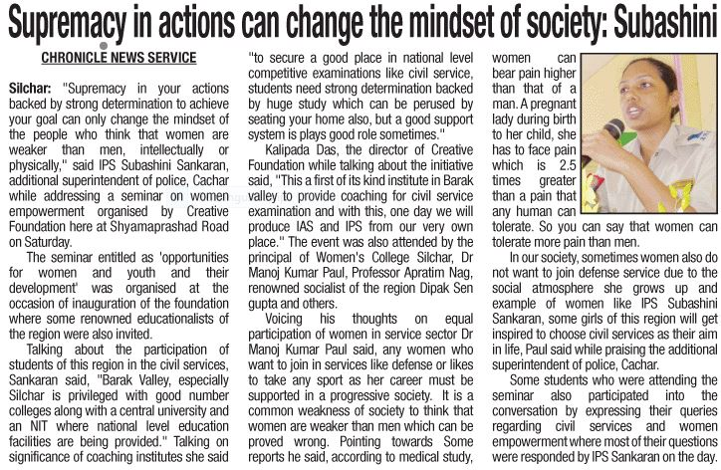

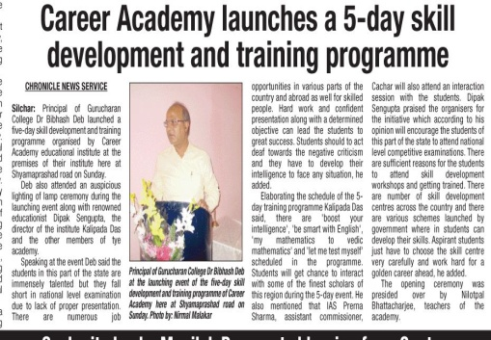

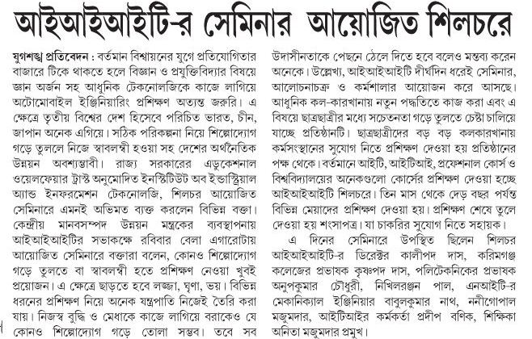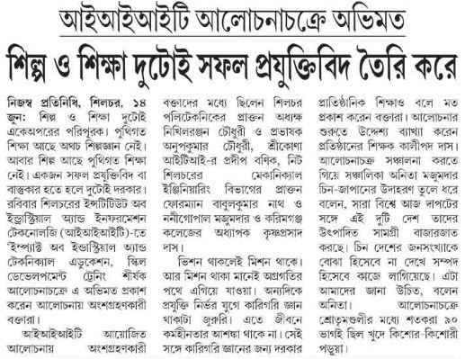



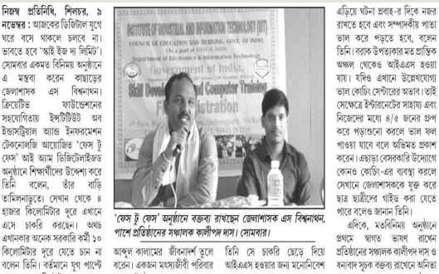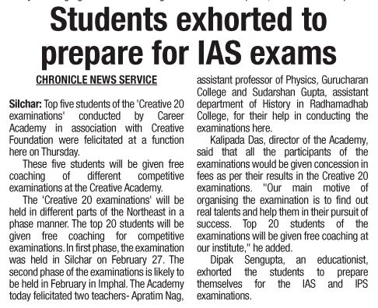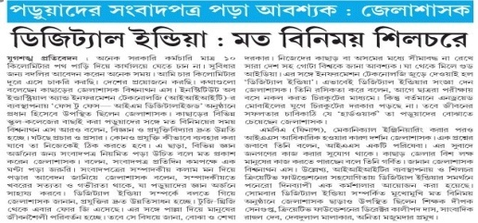

My Journey with CREATIVE Foundation:

**I have started my journey with creative foundation one year back and I think it is one of my biggest achievement of life. From the beginning I am very happy to work with the foundation and our hard work is the result of the foundation’s fine reputation today.**

**It was envisaged that creative foundation would lay added emphasis on the development of the weaker sections of the society through proper education targeted towards attainment of self-reliance and self sufficiency. Education and its application towards social development and upliftment require proper focus on creative work and its application. Hence creative foundation encompasses all such activities which establish a meaningful name of the foundation.**

**Subrata Dey**

**A FEW WORDS ON VOLUNTARY BLOOD DONATIONS**

*Paritosh Chandra Dutta S. S. College, Hailakandi Assam - 788151*

=================================================================================

*“We cannot live only for ourselves. A thousand fibers connect us with our fellow human beings.”* Herman Melville

Blood is the life maintaining fluid that circulates through the body is universally recognized as the most precious element without which the human life never sustains. It saves innumerable lives across the world in a variety of conditions. It is the life-maintaining fluid that circulates through the body's heart, arteries, veins and capillaries. Human blood is made up of two distinct components: cells and fluid. The cellular portion of blood includes red blood cells, white blood cells, and platelets. Generally, the fluid portion of the blood is called plasma and is made up of various non-cellular materials.

The need for blood is constantly increasing the world over. Apart from diseases like dengue, millions lose their lives to natural and man-made disasters. The number of people dying in road accidents is also growing. Despite being a country with a population of 1.2 billion, India faces a blood shortage of 3 million units. The problem can be addressed if an additional two percent of Indians donate blood, health experts say. The World Health Organization set a goal in 1997 for all blood donations to come from unpaid volunteer donors, but as of 2006, only 49 of 124 countries surveyed had established this as a standard. Against an annual demand of 12.5 million units, India is able to collect only 9.2 million units of which 65per cent is from voluntary blood donors while the remaining 25 per cent is from family/replacement donors. The Indian Red Cross Society has 166 blood banks all over the country, where the voluntary blood donation is 90 per cent.

Donation of blood is a sign of kindness and care for the fellow human beings. There is no gift more valuable than a Gift of Blood, as it is actually a Gift of Life for the person who receives it. Voluntary blood donation is undoubtedly, the highest form of humanitarian service as it is done without expectation of even knowing who it will help. One single blood donation actually helps at least three patients as blood is usually segregated into Red Blood Cells, Platelets, White Blood Cells and Plasma and given accordingly for their requirement.

There are many advantages of donating blood regularly .The first and foremost advantage of donating blood is, no doubt, the exhilarating feeling of having saved someone's life. Donating blood keeps us healthy because new blood is formed in our body. By donating blood, it removes impure blood present in our body.Blood donation is an excellent way to reduce the amount of iron accumulated in our body while iron isnodoubt a necessary mineral. But excess iron can stimulate the formation of free radicals which can cause damage to the body tissues. Hemochromatosis is a genetic disease characterized by excess accumulation of iron in the tissues due to improper metabolism. The disease damages many important organs, such as the pancreas, adrenal glands, etc. It may also cause diabetes, liver disease and heart diseases. Donating blood on a regular basis helps regulate the level of iron in the donor's body.

Less than 1 per cent of the eligible Indian population donates blood every year which is far less than the average rate of 5 per cent in the Western world. It makes no difference at all!  after donation but the donor is advised to take rest for at least 10 minutes and to take refreshment that supplied in the donation camp. The whole process of donation takes about 30 minutes. We will not feel drained or tired if we continue to drink fluids and have a normal meal. It can be resumed our normal activities after donating blood, though it is being asked to refrain from exercise or heavy weight lifting for twelve hours after donation.

However, I may be temporarily deferred from donation if myself.. . i) isexperiencing symptoms of a cold or sore throat , ii) is taking antibiotics for an infection. Iii) have taken aspirin or aspirin-containing medications within the previous 48 hours, iv) have donated whole blood within the previous eight weeks or platelets within the previous two weeks, v) did not sleep well in the last night, vi) have in empty stomach and vii ) haveany kind of interior or exterior mouth sores.

Any person who wants to donate blood should

1. be in good general health
2. have aged 18 years older but less than 65 years
3. have weight at least 45 Kg
4. have a haemoglobin level of 12.5 g/dl
5. not have donated blood in the last 12 weeks.
6. eat a meal within four hours of donation

However, following are the some points which should be remembered before donating blood voluntarily:

1. Please have a good meal at least 3 hours before donating blood.
2. Please accept the refreshments offered after the donation. It is recommended to have a good meal later.
3. Please avoid smoking on the day before donating. One can smoke 3 hours after donation.
4. One is not eligible to donate blood if he/she consumed alcohol 48 hours before donation.
5. Please drink sufficient quantity of water before and after the donation

The voluntary blood donation movement in Assam was mooted in the wake of Sino-Indian war in 1962. Voluntary Blood Donors Association was formed in the year 1988 at Guwahati comprising the like minded voluntary organisation like Red Cross Society, Lions Club, Rotary Club, AASU, Nursing association etc. Assam is still lagging behind in regard to Voluntary Blood Donation. Voluntary Blood Donation Movement, in the proper sense, started in the Barak Valley with the formation of Barak Valley Voluntary Blood Donors’ Forum which started its journey on the 19th May, 2002 by organizing blood donation camp at Silchar.The people of the valley are extending cooperation to upgrade the movement of voluntary blood donation. It is to be noted that Dakkhin Assam AkhandaMandali organising blood donation camps since 2012 where for the first time 267 donors donated blood while in the year 2015, the number of donors decreased to 160. It is important to note that the G.C. College Silchar organised camps in the year 2013 and 2015 where 216 and 265 donors donated voluntarily. During the year 2014-15, Cachar district Committee organised 13 camps through which 502 units of blood were collected while the number of donors increased to 862 through 23 camps during the year 2015-16.

However, One Blood Donation Camp was organised by Blood Mouth Club of Hailakandi in the year 1998 by the initiative of Mr.Sanjib Chandra which may be considered as the first voluntary Blood Donation Camp at Barak Valley. Again, Hailakandi Branch of Assam Science Society which took birth at Hailakandi with the heartfelt initiative of Professor Bijit Kumar Bhattacharjee in the year 1997-98 also organised Blood grouping Camps in different institutions of the district including RabindraMela etc. from the year 2000 which helped to expedite the blood donation movement in the district under the banner of Barak Valley Voluntary Blood Donors’ Forum. However, the number of camps and the number of voluntary donors are increasing gradually at Hailakandi. During the year 2014-15 Hailakandi Branch of the Forum organised 16 camps where 505 number of voluntary donors donated blood and during the year 2015-16 , the number of camps increased to 22 where 776 volunteers donated blood. Consciousness about blood donation is gradually developing in the minds of the people of the valley and it is hoped that India today has just about 4 voluntary blood donors per 1000 population as against 70 in Japan and 113 in Switzerland. For India, this needs to rise to around **30 per 1,000** for total self-sufficiency. The Young’s of the country should come forward and donate blood voluntarily to save lives. It should be always keep in mind that – “Service to mankind is service to God” and thus all the young’s are requested to donate Blood for Saving Lives. Lastly, it can be concluded with the following lines --

***To the young and healthy it’s no loss. To sick it’s hope of life. Thus Donate Blood to Give Back Life***

***❖❖❖❖❖❖❖==❖❖❖❖❖❖❖***

***Message From Dreamland***

***Anita Mazumder***

It was later part of February 2015, when I was introduced with a person who in his youth had dream which I could visualize with my inner vision .He met me, told me lot about his dream, which to me were nothing more than day dream, as if I had deigned in his own style of thinking, vision and imagination .Unlike the other professional institute it was not meant to earn profit but to cater the social need to uplift the talented students of economically insolvent families. He was the person who started dreaming to start an institute to coach students of this place for I.A.S and I.P.S Exam .His dreams were highly endorsed by I.P.S officer Suhashini Shankaran and I.A.S officer S .Viswanathan.His concern for ill-fated youth of this region motivated him to arrange workshop on various vocational streams which are highly appreciated by Hon’ble chairman Silchar municipality, his personal visit in spite of busy schedule proves beyond doubt that his dream could touch the heart of Hon’ble chairman sir .In this 365 days many luminaries of academic arena visited the institute and have become strange to see the institute which is unique in his own field .Myself in 365 days witnessed each and every day struggle and also achievements which made me smile ,joyful,enthusiastic,optimist and confident. Now I have started believing that to make our human life significant many thing must be done with a positive mind .I have learnt relentless struggle never goes in vain .Now let me unfold the mystery disclosing the name of the person he is none other than KALIPADA DAS, to many K.P Sir who happens to be my younger brother too. I sincerely wish his success will open a new horizon to the youth of this region.

**Flash light on Career option: A new Look**

**Deepak Sengupta, Adhar Chand H.S School**

**===============================================================**

With the passage of time , values , outlook , socio economic condition changes but in remote corner of the country , no such significant change has been observed for last few decades . To be specific about career options are concerned the students and guardians have two way traffic one ends in medical colleges and other in engineering colleges . But it is a matter of fact that in between these two ways there are many lanes and sub lanes which in no way undermines the dignity of life and its ease and comfort. These alternative options are to be searched . It is a wrong concept that there exist no better option other than these two as has been mentioned , in fact there are many options which remain unexplored . Graduation now a days in any discipline acts as a passport to get entry to the broader world . let me be more specific for example any engineering graduate as well as medical graduate even graduate from general stream is sufficient qualification to appear for and to crack prestigious competitive examination , if this be the situation then craze for medical and engineering bear no significance at all . Instead of giving more effort to these professional courses if one devotes totally for preparing for civil service examinations , bank P.O examination and other allied examination one can reach zenith of his career life . This simple truth if one realize by heart then one can face any odds and provocation , temptation . Further , other than few very common branches of engineering like civil , mechanical , electrical , computer etc courses like paper , printing , plastic , textile technology also fed the respective industry with good human resource . Going beyond science and technology there are so many disciplines in humanities ( arts) like mass communication etc which not only directs profession but also give exposure to society , Arnab goswami , Pronoy roy , Rajib sardeshai are few known faces who have become icon , in this context it is to be noted that Arnab goswami hails from Assam . In any corporate sector the inner fight between technocrat , managerial personalities , at last managerial personalities wins . Understanding this fact many are opting for M.B.A studies , even medical graduate go for M.B.A . In this scenario many B- school of national and international reputation are offering management courses , but for that candidates must survive in competition scoring good marks in CAT and MAT examinations . Many candidates without taking pain to survive in completion get trapped by low ranking B- school , someone even get trapped by fake institution exhausting their financial solvency or becoming over burdened with bank debt . With the opening of new branches like bio informatics , B –pharma etc students are facing comparatively less competition at entry level . These courses also provide better research facility and job opportunity . So at the last I like to conclude with a optimist message even at this stage of intense competition , job crunch , population explosion , economic recession the present generation will find their own way of struggle and following the rule of survival of fittest they will survive . This is the lesson of history.

हसना मना है

सुप्रतिम सेन, आई आई आई टी सिलचर

एक पुलिस वाला रोड पर खड़ा था

एक आदमी आया और उनसे बोला..  
भैयाजी, हम आपको रोड क्रॉस करवादें…

पुलिस वाला बोला: तुम काहे करवाओगे भैया, हम खुद करलेंगे.आदमी बोला:  
तुम कैसे करोगे, कानून तो अँधा होता है!

DILIGENCE IS THE MOTHER OF SUCCESS

Thoiba Singha, Senior Faculty, IIIT Silchar

There can’t be any short cut to success. The toil of years, the sweat of yours brow, struggle you make, everything counts in achieving the goal. Looking at the biographies of greatmen, we find that most of the successful person, whatever their field, inventors, artist, scientist, technocrats, sculptors, thinkers leaders & workers of any kind, owe their success to their indefatigable hardwork & dedication. They were the man who achieved their success with dedication, devotion & true hard work. These really proves that the secret of success consists in being master of our subject. Such mastery is attainable through continuous application & study.

Those, who work diligently, not only achieve their goals & get success, but also remain happy, cheerful & active, which is itself a great reward even if the work does not bring success. Idleness or Laziness is worse as it brings jealously, gloom, frustration, depression which are more degrading than the failure itself.

Walter Scott,the famous novelist of Scotland, who started his life as an ordinary clerkattained the great heights of eminence by dint of his sheer diligence.He used to rise 5 o’clock and by the time his family assembled for breakfast, he had done enough, to use his own words, the break the neck of the day’s work.

Excellence is an ever approaching target. One who puts his best in pursuit of excellence, he reaches nearer to goal. Full dedication, high degree of devotion, cuts times to half. A glimpse of history tells us that all the successful personalities are determined & devoted fully to achieve whatever they thought or desired.

See the example of Dhirubhai Ambani who put the Reliance group in the fortune 500 companies, started with an investment of Rs.15000 & made it a company of Rs. 60000 crores. It looks unimaginable, unbelievable but it is a fact. The diligence of Mr. Ambani, his full dedication and devotion to do something extra ordinary, raise him to such unimaginable heights.

Enthusiasm is the best asset of a person, & self determination and hard work, could achieve anything. Failure of any kind doesn’t deter them but makes them more fierce and dedicated to achieve the goal. Failure are natural happenings. All successful men faced failures of many kind but they worked with more enthusiasm, more determined zeal, analyzed their shortcomings & tried again & got success.

Those who consider themselves born to ill luck, very wrongly assume that all their failures & misfortunes are because of their hard luck. They don’t analyze their weakness, shortcomings & lack of efforts but lament of their ill fate. Fate is nothing but a creation of an idle fancy, an invention of superstitious brains. Mr. Johnson, has rightly said,”All complains which are made of the world are unjust, I have never known a man of merit & diligence neglected; it was by his own fault that he failed of success. Several proverbs signify the importance of diligence: **No sweat no Sweet,** God helps those, who help themselves; The World isHis, who has Patience & Industry, Fortune favours the brave, perseverance & dedication are the keys to success. The proverbs are time &experience of everyday tested &still bear force of truth & accuracy.

One should not trifle away the importance of intelligence, along with diligence. Labor& hardwork pays when apply intelligently & analytically. Just as diligence alone can’t help in achieving success, in the same way intelligence alone can’t help in making one successful. It is the result of both diligence & intelligentsia, which makes a man successful. Taking right decision, at right time, in a right manner means intelligence & putting hard work to achieve a goal, undaunted by the problems which positive thinking & iron means diligence.

No doubt diligence is very necessary for success but intelligent decision is again an important factor that can’t be ignored. We know so many daily wage earners toiling hard day & night to earn their livelihood, but can’t be termed as successful, but a person putting little labour &managing the things properly, earning handsomely is a successful man. Thus, not only diligence but intelligence is also necessary for success in life.

*✡❖✡====✡*

*“Don’t take rest after your first victory because if you fail in second, more lips are waiting to say that your first victory was just luck.” -* ***A.P.J Abdul Kalam***

MOTIVATION

Ramanand Soibam, HS Second Year, Science, Creative Classes, Silchar

There was a young boy who came regularly to soccer practice but never made it to the starting team. While he was practicing, his father would sit at the far end of the field, waiting for him .The matches began and for four days the boy did not show up for practice or the quarter or semifinal .He appeared for the final game, went to the coach said,” coach! You have always kept me in reserve and never let me play.”The coach said ,”son! I am sorry, I can’t let you, there are better players than you and besides, it is the final; the reputation of the school is at stake, I cannot take a chance on you. “The boy pleaded, “coach! I promise I will not let you down ,I beg of you, Please let me play.” The coach had never seen the plead like this before, He said,”Okay son go play. But remember, I am going against my better judgement and the reputation of the school is at stake. Don’t let me down”

The game started and the boy played like a house on fire. Every time he got the ball, he shots a goal. Needless to say, he was the star of the game. His team had a spectacular win. When the game finished, the coach went up to him and said, “son how could I have been so wrong? I never saw you play like this before. What happened? How did you play so well?’’

The coach turned around and looked at the place where the boy’s father used to sit. There was no one there. He said, ‘’son, your father used to sit there when you came for practice, but I don’t see anyone there today‘’. The boy replied,”coach, there is something I never told you. My father was blind just four days ago, he died. Today is the first day he is watching me from above”

“**I believe in god, but not in his miracle because miracle is the name of hard work “.**

**🕮🕮🕮=❖=🕮🕮🕮**

**LIFE**

Shah nur Alam Laskar. DCHN, IIIT, SILCHAR

Life is a game,

Where you have to play

For name and fame.

Life is an adventure,

Where you don’t know your future.  
Life is a journey,

Where you have to tread a long way.

Life is a quest__

That draws us from the beginning to the end.

✡✡✡==✡✡✡

My Inspiration

Suman Paul,Student,Career Academy Silchar

❖“The goal of mankind is knowledge . . . What man "learns" is really what he discovers by taking the cover off his own soul, which is a mine of infinite knowledge.”

**Swami Vivekanada**

❖Everything comes to us that belongs to us if we create the capacity to receive it.

**RabindranathTagore**❖‘Reality is, after all, too big for our frail understanding to fully comprehend. Nevertheless, we have to build our life on the theory, which contains the maximum truth. We cannot sit still because we cannot, or do not, know the Absolute Truth.’

**Netaji Subhash Chandra Bose**

Visitors of the Year

1. S. Viswanathan, IAS, Deputy commissioner Cachar

2. Suhashini Shankaran, IPS, SP Hailakandi

3. Niharendra Narayan Thakur, Chairman SMB

4. Tushar Kanti Chakraborty, Asst. Director MSME.

5. Dr. Satyabhushan Paul, Ex controller of Examinations, Assam university

6. Dr. Pankaj Debsharma, Associate Professor, Assam University.

7. Krishnendu Kundu, Asst. Professor, UEM, Jaipur

8.Dr. Bivash Deb, Principal, G.C College Silchar

9.Dr. Monaj Paul, Principal Women’s College.

10. Nikhil Ranjan Choudhury, Ex Principal, Silchar Polytechnic

11. S.R Rajkumar, HOD, Dept of Com. Sc., Sri Venkataswera College, Chitoor.

12.Dipali Das, Supervisor ITI Srikona.

13.Samir Kumar Das, Ex principal, Narshing H.S School

14. Dr. Apratim Nag, Asst. Professor, G.C College.

15.Dr. Sushil Paul, Ex. Asst. Professor , G.C College.

16.Ajoy Roy, Asst. professor, Cachar College.

17.Sudarshan Gupta, Asst. Professor. Radhamadhav College

18.Krishnapada Das, Asst. professor, Karmganj College,Karimganj.

19.Dr. Paritosh Ch. Dutta, Asst. professor S.S College, Hailakandi

20. Babul Kumar Nath,Ex. Foreman NIT Silchar

21. Tuhina Sharma, Advocate, Silchar Bar Council

22.Nani Gopal Mazumder, Silchar Polytechnic.

23.Nilip Kumar Gour, Narshing H.S School

24. Anup Kumar Choudhury.Silchar Polytechnic

25.Prodip Banik, ITI Srikona

26.Krihna Bhattacharjee. Adhar Chand HS School.

27. Jagojyoti Bhattacharjee, Lead Distric Manager, UBI

And other distinguished persons. Thank you for your kind Visit

আত্মোপকারীকে বনবাসে বিসর্জন করা যাহাদিগের প্রকৃতি, তাহারা চিরকাল আত্মোপকারীকে বনবাসে দিবে – কিন্তু যতবার বনবাসিত করুক না কেন, পরের কাষ্ঠাহরণ করা যাহার স্বভাব, সে পুনর্বার পরের কাষ্ঠাহরণে যাইবে। তুমি অধম – তাই বলিয়া আমি উত্তম হইবো না কেন?”  বঙ্কিম চন্দ্র



